DAX basics in Power BI Desktop

DAX **Data Analysis Expressions** is a collection of functions, operators, and constants that can be used in a formula, or expression, to calculate and return one or more values. Stated more simply, DAX helps you create new information from data already in your model.

*DAX formulas use many of the same functions, operators, and syntax as Excel formulas. However, DAX functions are designed to work with relational data and perform more dynamic calculations as you interact with your reports. There are over 200 DAX functions that do everything from simple aggregations like sum and average to more complex statistical and filtering functions.*

It’s easy to create a new Power BI Desktop file and import some data into it. You can even create reports that show valuable insights without using any DAX formulas at all. But, what if you need to analyse growth percentage across product categories and for different date ranges? Or, you need to calculate year-over-year growth compared to market trends? DAX formulas provide this capability and many other important capabilities as well. Learning how to create effective DAX formulas will help you get the most out of your data. When you get the information you need, you can begin to solve real business problems that affect your bottom line. This is the power of Power BI, and DAX will help you get there.

**Data Link for This LAB:**

<https://download.microsoft.com/download/4/6/A/46AB5E74-50F6-4761-8EDB-5AE077FD603C/Contoso%20Sales%20for%20Power%20BI%20Designer.zip>

### **Syntax**

Before you create your own formulas, let’s take a look at DAX formula syntax. Syntax includes the various elements that make up a formula, or more simply, how the formula is written. For example, here's a simple DAX formula for a measure:

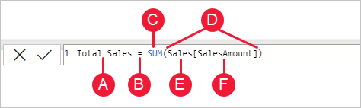

This formula includes the following syntax elements:

**A.** The measure name, **Total Sales**.

**B.** The equals sign operator (**=**), which indicates the beginning of the formula. When calculated, it will return a result.

**C.** The DAX function **SUM**, which adds up all of the numbers in the **Sales[SalesAmount]** column. You’ll learn more about functions later.

**D.** Parenthesis **()**, which surround an expression that contains one or more arguments. Most functions require at least one argument. An argument passes a value to a function.

**E.** The referenced table, **Sales**.

**F.** The referenced column, **[SalesAmount]**, in the Sales table. With this argument, the SUM function knows on which column to aggregate a SUM.

*When trying to understand a DAX formula, it's often helpful to break down each of the elements into a language you think and speak every day. For example, you can read this formula as:*

For the measure named Total Sales, calculate (=) the SUM of values in the [SalesAmount ] column in the Sales table.

### **Quick measures**

Many common calculations are available as quick measures, which write the DAX formulas for you based on your inputs in a window. These quick, powerful calculations are also great for learning DAX or seeding your own customized measures.

Create a quick measure using one of these methods:

* From a table in the **Fields** pane, right-click or select **More options** (**...**), and then select **New quick measure** from the list.
* Under **Calculations** in the **Home** tab of the Power BI Desktop ribbon, select **New Quick Measure**.

## Quick measure example

Let's take a look at a quick measure in action.

The following matrix visual shows a sales table for various products. It's a basic table that includes the sales totals for each category.

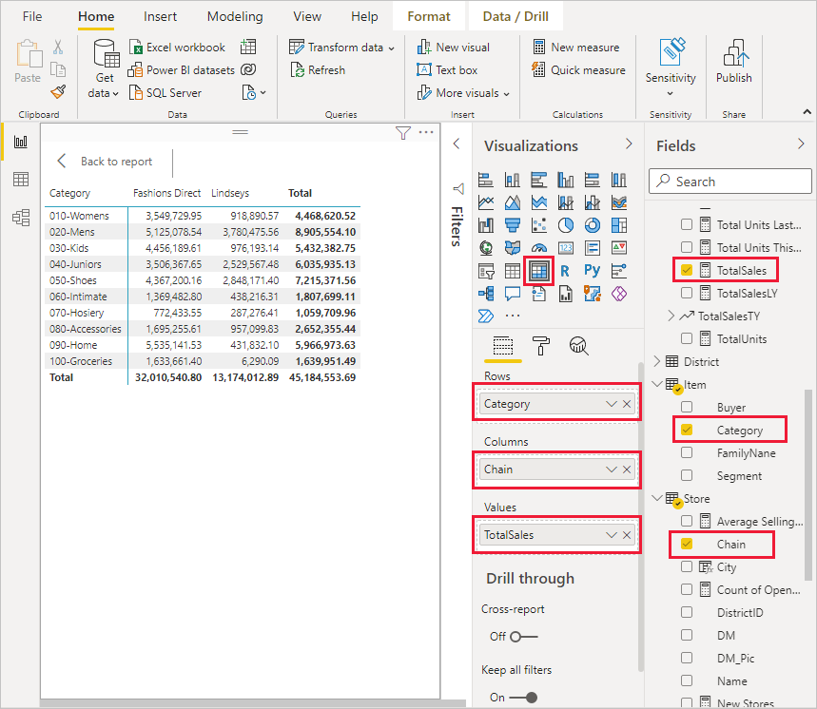

With the matrix visual selected, select the drop-down arrow next to **TotalSales** in the **Values** well, and select **New quick measure**.

In the **Quick measures** window, under **Calculation**, select **Average per category**.

Drag **Average Unit Price** from the **Fields** pane into the **Base value** field. Leave **Category** in the **Category** field, and select **OK**.

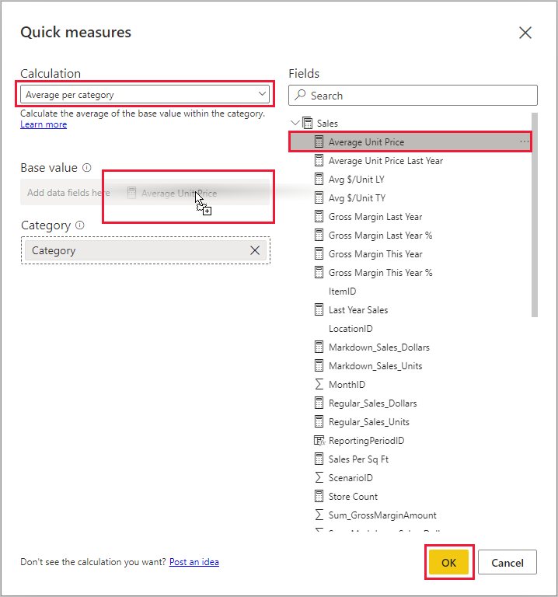

When you select **OK**, several interesting things happen.

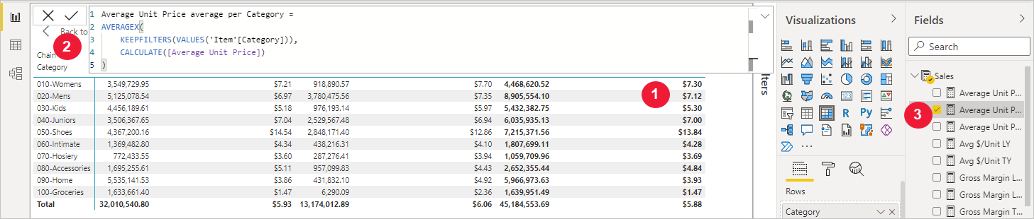

1. The matrix visual has a new column that shows the calculated **Average Unit Price average per Category**.
2. The DAX formula for the new quick measure appears in the formula bar.
3. The new quick measure appears selected and highlighted in the **Fields** pane.

The new quick measure is available to any visual in the report, not just the visual you created it for. The following image shows a quick column chart visual created by using the new quick measure field.

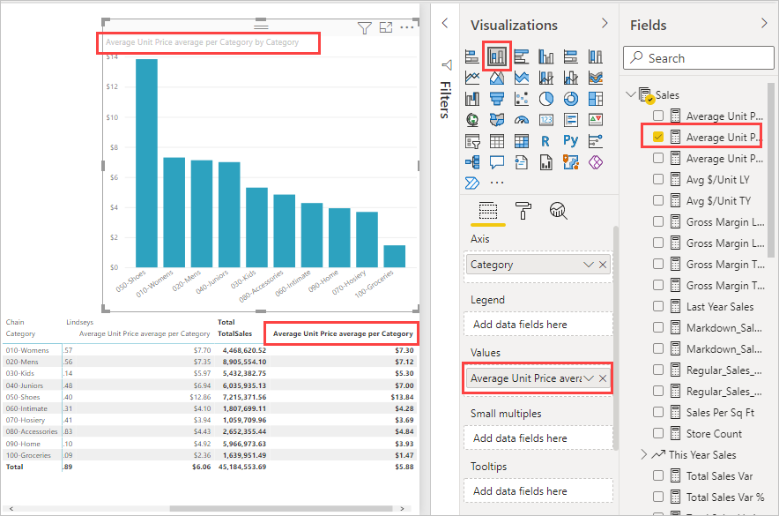

## Learn DAX by using quick measures

A great advantage of quick measures is that they show you the DAX formula that implements the measure. When you select a quick measure in the **Fields** pane, the **Formula bar** appears, showing the DAX formula that Power BI created to implement the measure.

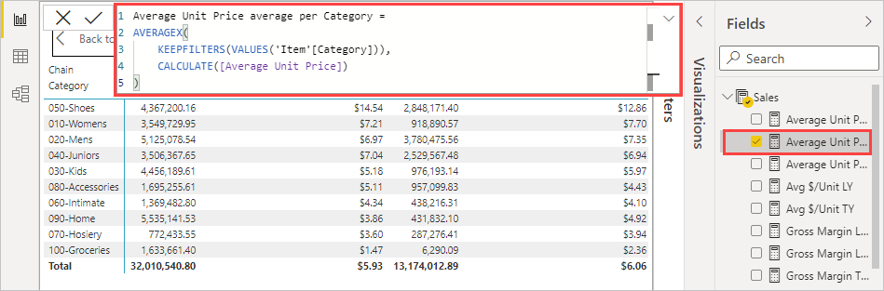

The formula bar not only shows you the formula behind the measure, but perhaps more importantly, lets you see how to create the DAX formulas underlying quick measures.

Imagine you need to do a year-over-year calculation, but you're not sure how to structure the DAX formula, or you have no idea where to start. Instead of banging your head on the desk, you can create a quick measure using the **Year-over-year change** calculation, and see how it appears in your visual and how the DAX formula works. Then you can either make changes directly to the DAX formula, or create a similar measure that meets your needs and expectations. It's like having a teacher that immediately responds to what-if questions you ask with a few clicks.

You can always delete quick measures from your model if you don't like them. That's as easy as right-clicking or selecting the **...** next to the measure and selecting **Delete from model**. You can also rename a quick measure whatever you like by selecting **Rename** from the menu.

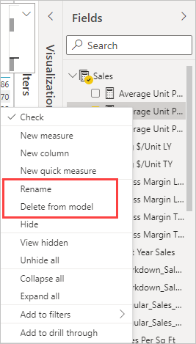

## Considerations and limitations

There are a few considerations and limitations to keep in mind.

* You can use quick measures added to the **Fields** pane with any visual in the report.
* You can always see the DAX associated with a quick measure by selecting the measure in the **Fields** list and looking at the formula in the formula bar.
* Quick measures are only available if you can modify the model. That isn't the case when you're working with some Live connections. SSAS tabular live connections are supported, as previously described.
* You can't create time intelligence quick measures when working in DirectQuery mode. The DAX functions used in these quick measures have performance implications when translated into the T-SQL statements that are sent to your data source.